Nicolas Brooks

Professor Anandarajan

Independent Study

Summer 2017

Natural Language Processing with Retail Data

Project Github: <https://github.com/nicapotato/Jupyter/tree/master/NLP/Retail%20Project>

Introduction:

This independent study is concerned with using Python and Natural Language Processing technology to explore trends in the customer reviews from a women’s clothing retail store, and extract actionable plans to improve its online e-commerce. The data is a collection of 23,486 comments with 17 featured variables. The total number of unique words in the dataset is 9810. In this analysis, the data will be introduced using exploratory data analysis, and proceed to employing frequency distribution, Word Clouds, Sentiment Analysis, Naive Bayes, and finally Word2Vec to find actionable findings.

Variables and Processing:

The first step is to address the the variables and dive into the pre-processing steps necessary to turn raw text into valuable output. This dataset’s notable variables include: review title and review body of clothing product, rating assigned to the product, age of customer, whether the product was recommended, and finally department and division.

In order to facilitate the use of sentiment analysis, a new boolean variable is created to categories good and bad reviews. All reviews with a rating of 3 and over, were deemed good, and reviews under 3 deemed bad. This step is especially important for the use of Naive Bayes’ supervised learning algorithm, since it requires a clear binary label to train upon.

In order to process the dataset’s centerpiece, the review body, I utilized the NLTK package to lowercase, tokenize, and remove stopwords and punctuation. Tokenizing treats each word as its own value, while the other steps gets rid of the noise and irrelevant symbols in the data, standardizing the reviews for analysis. Upon reviewing the performance of text analysis, I decided to implement the Porter Stemmer on the tokens in order to combine words with tense and plurality deviance. I contemplated exploring the use of sequential models, such as Long Short-term memory, which would benefit from stopwords, but unfortunately I could only find predictive applications of it, no insight extracting aspects.

The last piece of data transformation conducted was to bin the continuous variable age into a categorical variable: age category.

Exploratory Data Analysis:

The vast majority of reviews were highly positive, with a score of five out of five. This suggests that this retail store is performing fairly well, but comparison to competitors would determine whether it is satisfactory. Competitor reviews may be scraped and analyzed. It is important to note that these reviews are subjective, and some negative reviews may a outcome of a bad day, instead of constructive feedback. In the plot below, the Label plot is the binary classification of 1 = good, and 0= bad.

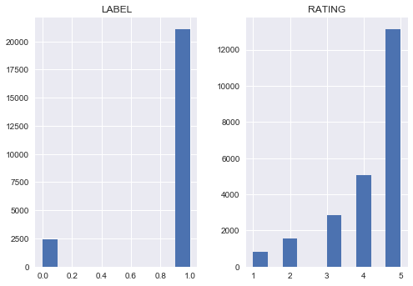

Sentiment Analysis:

Because the data sentiment is already outlined by the rating category, the use of sentiment analysis is redundant. Nevertheless, since this is my first time doing Natural Language Processing and programming with Python, I am eager enough to play around with the technology, and see how well it compares to customer labeling. Just like the rating, sentiment analysis classified just over 20,000 positive reviews, suggesting that sentiment analysis is a valid technology to on product reviews without labels, such as facebook or twitter reviews. The creation of a lexicon may also prove useful in analyzing competitor reviews.

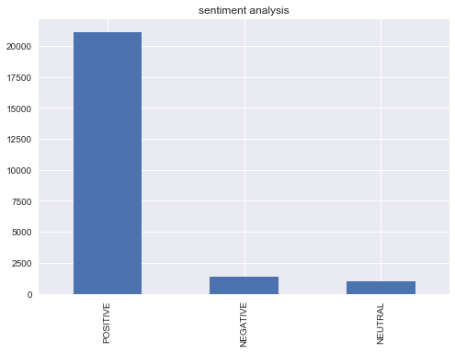

Age Variable:

Now that I know the distribution of reviews, I am curious to find out the role played by customer age:

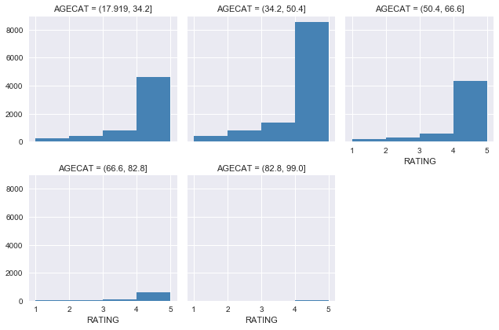

My a priori expectation was that the biggest group of reviewing customers would be young, tech savvy women between the age of 18 and 34. However, this plot would say otherwise, since it appears that not only is the 34 to 50 year old age most engage in reviewing products, they also appear to be the most positive reviewers, since they proportionately give higher more reviews of 5. Before making insight about these point, it would be wise to gather further data on the age distribution of shoppers. Nevertheless, this trend suggest that the core market segment for this clothing brand is women between 34 and 50.

Clothing Type Variable:

Exploring the class variable suggests that the most popular clothing types are: Petite and Anthro, Dresses, Blouses, and Cut and Sew Knits. The distribution of reviews is fairly constant, suggesting that there are not negative nor positive outliers. This statement has been further verified by taking the mean of the label by class group. The results show that no class falls above .80, and the majority rest at .90. Casual bottoms and Chemises scored the highest in this criteria with a 100% positive review rate, however upon investigation this is because only 4 reviews were made in these categories.

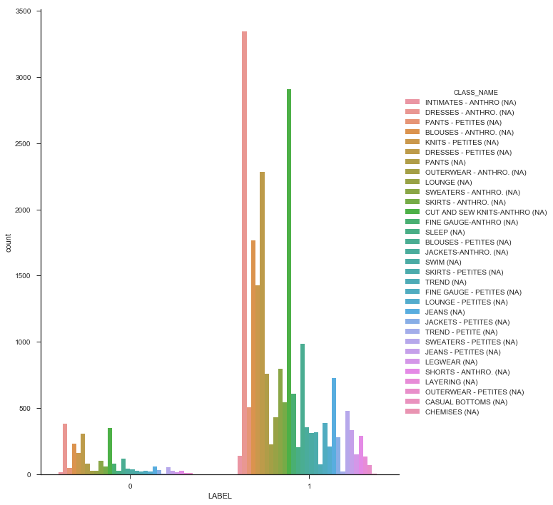

Word Clouds:

Now that a general understanding of the bariables have been laid out, I will begin to analysis the customer reviews. Using the categories good and bad, I created two separate word clouds.

**Positive:**

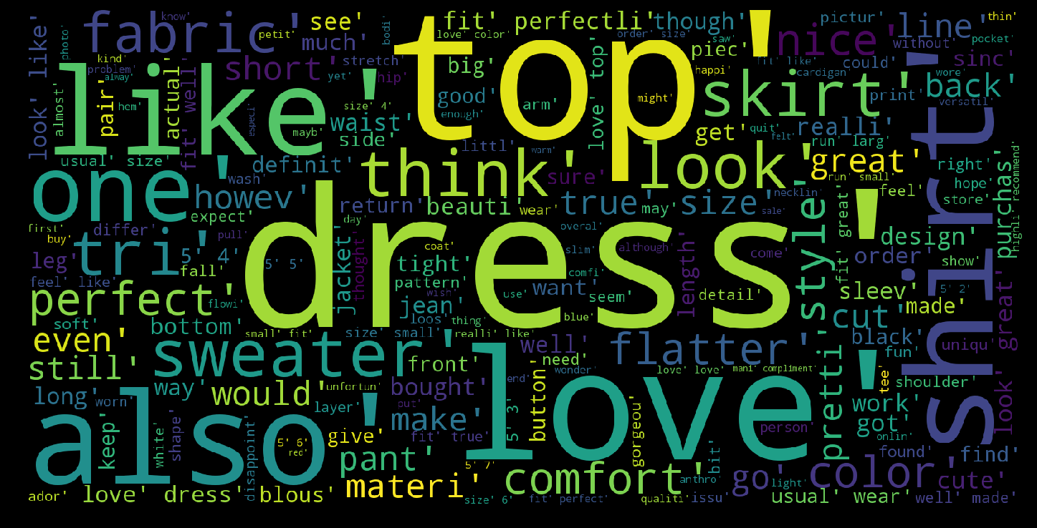

**Negative:**

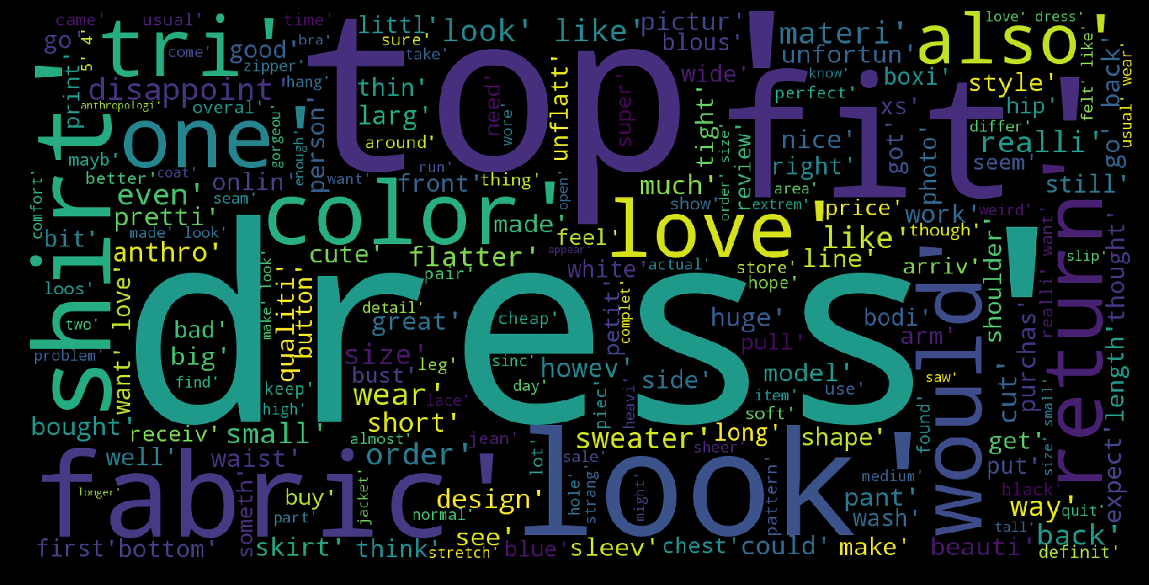

At a first glance the most common words overlap significantly between good and bad reviews. Indeed, the observation that “Dress” and “Top” are the most common words is reflected by the disproportionate number of reviews in the dress category. Looking at the rest of the words, the positive reviews tend to use words such as: Love, Comfortable, Great, Style, Small, Flattering, Wear, True. This offers the first big insight because within the expected positive words, the words “True” stands out, since it suggest consistency between customer expectation of the product and what the product actually delivered. In terms of negative reviews, notable words include: unflattering, big, unfortunately appear. These negative words represent the small proportion of words in the negative reviews. This suggests that either people are expressing their criticism with negative prefixes, such as “Not Pretty”, or people are sticking to constructive criticism only, addressing problems of fit or appearance rather than simply expressing anger.

The central flaw of these word clouds is that they are only show the distribution of individual words. This removes the context of the word, as well as disregard negative prefixes. In order to solve this problem I will utilize n-grams, which increases the size of observed values from one word to multiple words, enabling frequency counts to be conducted to word sequences. Although I would have prefered to visualize these findings through the use of Word Clouds, I was unable to program this, thus leaving me with a simple table.

In the table below, the 15th most frequent 2 and 3 gram sequences are on display for both the good and bad reviews.

N-Grams: Gram and Frequency

|  |  |
| --- | --- |
| **Negative** | **Positive** |
|  |  |

At this point, fit and product inconsistency strongly emerge as major topics in the reviews. From this information, I can infer that the dataset belongs to a online retailer, since brick and mortar stores have changing rooms to prevent this problem. The central themes in the product reviews brought to light by the n-grams are:

1. **Fit:** Whether the product’s advertised size actually corresponds to customer size and height.
2. **Love or Hate:** The customer's personal feelings towards the product.
3. **Complements:** The customer's social experience wearing the product.
4. **Product consistency:** Whether the product appears as advertised, lives up to quality expectations.

In the negative reviews, customers expresse their disappointment in the product, stating that they “really wanted to love” the item. This signifies that the product did not live up to the customers expectations. This occurred for multiple reasons. “Order wear size” and “Usual wear size” suggest that the fit did not suit their typical universal body size. Perhaps if better product dimension information could be provided, then the likelihood of this negative response could decrease. Furthermore, perhaps the product platform could track the user’s size through previous purchase in order to warn customer for potential size conflict.

Another form of negative review is in the dissapointment in the product turnout. “Too much fabric” and “Looks nothing like” suggest inconsistency with online retail presentation and actual product. These reviews are especially destructive, since they damage the reputation of the store product quality, which is a online platforms biggest asset.

On the other hand, positive reviews are void of criticism, and are preoccupied with confirming fit and sharing social experience with the clothing. “True Size”, “Fit Perfectly”, “Fit like a glove”, on top of the multiple 2-grams with customer’s height suggest that a large part of positive reviews are employed to confirm product fit according to certain size. The high occurrence of this review suggest that height and size is usually a big issue, which this retail managed to consistently satisfy.

“Received many compliments”, “Look forward to wearing”, “Everytime I wear”, “Looks great with jeans” are all comments which reflect the customer's experience wearing the product out in public. This not only express the relevance of trendy, jaw dropping fashion for customers in a social context, but also suggests that the product review are a highly social space, in which customers not only talk with the retailer, but with the other customers as well.

Naive Bayes Algorithm: Extracting meaning using supervised learning

Supervised learning is typically employed to make predictions about the future. However, some simple models may also be opened up to offer some insight. Naive Bayes is a probabilistic model which depends on Bayes theorem to compute the probability of a word's category by looking at its occurrence over the different classes. Since this model looks at both good and bad reviews, it is able to extract the one-gram tokens which best polarize the categories. Using this model, I could potentially predict the positive or negative sentiment of unlabelled reviews.

Table Interpretations:

The first column displays the word, the second represents whether the word is negative (0:1), or positive (1:0). Lastly, the third column shows the ratio of occurrence. Looking at the first column, “worst” is a negative word, whose presence indicates the review is 34 times more likely to be negative than positive.This model’s accuracy is 89%. Naive Bayes’ predictive power is limited compared to other, more complex models, but accuracy is not the goal for this analysis.

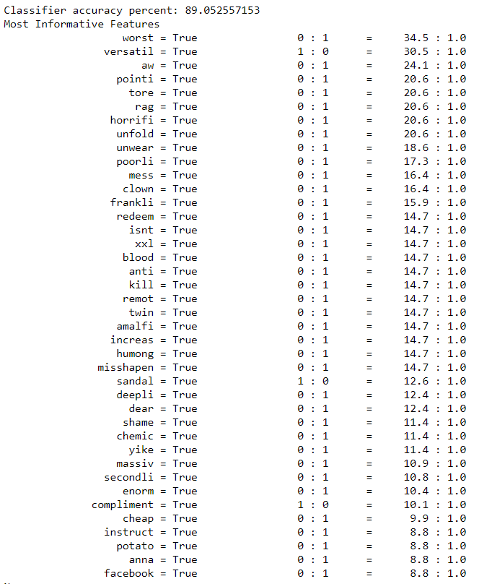

The forty most polarizing words found by the algorithm are mostly negative words. This is perhaps because the imbalanced distribution of positive and negative review. Since negative words to be less represented, rare words may stand out more. The positive word “Versatile” suggests that cloths which can be matched with a broad wardrobe are deserving of a good review. Product marketing should aim to associate itself with this word, since it is undeniable positive association. The second word “Compliment” is consistent with the n-gram analysis, and once again highlights the value of a positive social experience.

Negative words on the other hand, are much more numerous and suggest a wider range of emotions. “Worst” and “Kill” are fairly self explanatory, outright negative emotion without constructive feedback. “Aw”, “Redeem”, “Misshapen”, “Shame”, and “Dear” evoke much deeper emotions of disappointment and sadness, but since the customers are expressing a more rational, critical response, perhaps redemption on the part of the retailer is possible, contrary to hateful customer’s reviews. For these reasons, a classification model which can flag negative reviews of this sort may not only convert this disappointed customer into a loyal one, but it may also serve as a strong PR move which can boost the positivity in the comment section, which has proven to an influential social space for customers.

At the bottom of the Naive Bayes’ most polarized words are the negative words “Potato” and “Facebook”. This is quite comical, since these words suggest a divergence from the traditional review vocabulary into the lingo of internet memes and social media. Indeed, teenagers and young adults who frequently image sharing sites like to label crappy, passive things as “potato”.

Word2Vec: Neural Network

In order to gain more insight about these words, Word2Vec will be utilized. This model uses a shallow neural network to find words which emerge in similar context. By embedding words through multiple dimensions, similar words may be extracted. My analysis fetched the ten most similar words.

|  |  |
| --- | --- |
| **Negative Word** | **Similar Words** |
| shame | [('mainli', 0.9287949800491333),  ('reluctantli', 0.9152017831802368),  ('crook', 0.91181480884552),  ('de', 0.899941086769104),  ('integr', 0.897300124168396),  ('clip', 0.8968260288238525),  ('wonki', 0.8967447280883789),  ('jut', 0.8963980674743652),  ('none', 0.8952524662017822),  ('repair', 0.8950567245483398)] |
| potato | [('circu', 0.9277945160865784),  ('muumuu', 0.8956434726715088),  ('boxier', 0.8774730563163757),  ('giant', 0.8756405711174011),  ('sack', 0.873295783996582),  ('moo', 0.8720555305480957),  ('frankli', 0.8717751502990723),  ('grandma', 0.8660542964935303),  ('jut', 0.8647107481956482),  ('wing', 0.8616272211074829)] |
| worst | [('wonki', 0.9466806650161743),  ('reduc', 0.9427450299263),  ('seriou', 0.9401675462722778),  ('broken', 0.9369989633560181),  ('nightmar', 0.9369844794273376),  ('mainli', 0.9363988041877747),  ('embarrass', 0.9341127276420593),  ('bear', 0.9329415559768677),  ('scissor', 0.9302538633346558),  ('couch', 0.929938793182373)] |
| rag | [('bathrob', 0.9240034818649292),  ('hospit', 0.8915389776229858),  ('becau', 0.8900049924850464),  ('nightgown', 0.8853806853294373),  ('moo', 0.8792257308959961),  ('frequent', 0.8777855634689331),  ('sausag', 0.8763315081596375),  ('couldnt', 0.8722333908081055),  ('horrifi', 0.8718711137771606),  ('grate', 0.8691390752792358)] |

The word “Shame” is consistent with the emotion of disappointment, since it is associated with “Reluctantly” and “Repair”, which also suggest potential redemption. Word2Vec is great because it may be used to improve the detection of salvageable customers through broadening the words relevant to disappointment. “Worst”, “Rag”, and “Potato” are all similar to strictly negative words, although the latter two often have a comedic edge to them.

|  |  |
| --- | --- |
| **Word** | **Similar Words** |
| versatil | [('casual', 0.8894511461257935),  ('classi', 0.8763369917869568),  ('fun', 0.8689156174659729),  ('statement', 0.8675277829170227),  ('everyday', 0.8622598052024841),  ('dressi', 0.8553286790847778),  ('varieti', 0.83147132396698),  ('fanci', 0.8195697069168091),  ('throw', 0.8194319009780884),  ('chic', 0.8192055821418762)] |
| compliment | [('complement', 0.8592609763145447),  ('ton', 0.849358320236206),  ('ts', 0.7784327268600464),  ('numer', 0.7634919881820679),  ('galor', 0.6781098246574402),  ('stranger', 0.652309000492096),  ('mani', 0.6503288745880127),  ('load', 0.6384847164154053),  ('countless', 0.6369271278381348),  ('friend', 0.6330838799476624)] |
| love | [('ador', 0.841651201248169),  ('amaz', 0.7125707864761353),  ('gorgeou', 0.7103675603866577),  ('fabul', 0.6741998195648193),  ('beauti', 0.6554014086723328),  ('fantast', 0.6346416473388672),  ('classic', 0.6297193765640259),  ('wonder', 0.6152561902999878),  ('fun', 0.6076583862304688),  ('sweet', 0.6016392707824707)] |

In terms of positive words, “Compliments” has an interesting combination of words. Curiously, its association with “stranger” is a bit higher than “friend”, suggesting more instances of compliments from strangers. Otherwise, the most associated words are adjectives that signify quantity, such as “tons”, “many”, “load”, and “countless”.

Conclusion:

In the end, the most valuable findings came out of the n-grams, and the subsequent tools provided additional support to the findings. The n-grams highlighted the general themes of the reviews, including product fit, product compliments and social factor, and the product’s consistency. Fit is the product's biggest flaw since online shoppers are required to purchase without the ability to try. Since the customer often post their height and whether the product matches their size, further information could be mined in order to deter certain body heights and size from purchasing the product, or at least offer free returns in order to maintain customer confidence.

Since the n-gram analysis also suggests that a portion of negative reviews are motivated by product inconsistent with advertised version, a supervised learning algorithm (sentiment tracker) could be implemented in the real time in order to flag and promptly replace the flawed product mentioned in the complaints, or find other remedies. These comments are important to subdue because they offer the biggest threat to the retailer’s customer confidence, its reputation.

Another significant finding from this analysis is the importance of the social space created by the reviews system. These customers share their personal experience, suggesting that they are addressing other customers as well as the retailer. This could perhaps be capitalized on by increasing social capabilities of the review system, such as enable replies from other customers as well as open public dialogue with the retailer. This would enable the quick response to product inconsistency to become publicized, demonstrating to other users the initiative taken by the retailer. It would also provide more review data for collection, further improving the retailer’s understanding of it customer’s behavior. In order to prevent users to respond in mean or harsh ways, a filtering system should be incorporated to keep the space civil.

The n-gram analysis also pointed out that positive reviews often times emphasize compliments from strangers. Since the Naive Bayes also pointed out hyper positive words such as “versatile”, this information may be utilized in the marketing of the products. Furthermore, it demonstrates meaningful aspects of the product that should be utilized in customer testimonials.

Improvements:

This analysis was conducted at a fairly general level. Its core purpose was to explore the tools Python has to offer in the realm of Natural Language Processing. However, further analysis may be conducted, such as track down which class of clothing suffers the highest rates of product inconsistency, or perhaps which type of product receives the most compliments.

Although the PorterStemmer helped combine words of different tenses and plurality, it also makes the report harder to interpret, especially by decision makers unfamiliar with the technology. In terms of interpretability, the use of data tables may also be replaced by more intuitive visualization to increase understanding and rhetoric of communication.

Further variables may also be explored, such as department ID, or the level of activity of the customer at hand. This may offer insight on the customer satisfaction of certain departments, as well as the loyalty of the customers. A deeper dive in the clothing type may also have offered design insight, where customers criticism and praise are taken into account in the next product cycle.

Lastly, a lexicon for sentiment analysis could be built in order to extend the analysis of reviews to unlabeled facebook comments or tweets. The more data, the better the understanding of the situation.